Introduction

Preparation of plants and methods

Rocket stats

Motor
Motor: Cesaroni K1620 V-max
Total impulse: 2,439.6 Ns
Average thrust: 1619.5 N
Burn time: 1.5s
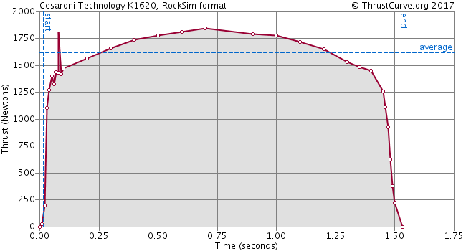
Rocket dimensions:

Length: idk
Mass with motors: about 11.8 kg (Pavel’s estimate)
Thrust to weight ratio: 14.0 (not sure this is right)

Recovery system: dual-deployment, redundant electronic charges. Drogue at apogee, main at 700 AGL. Both chutes deployed successfully.
Apogee: 4046 ft.
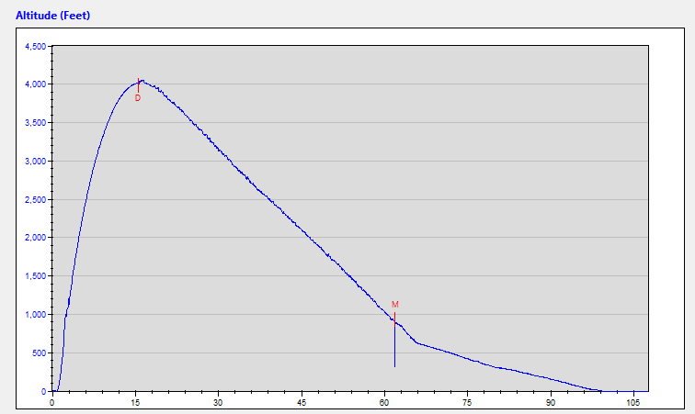
Curve 1
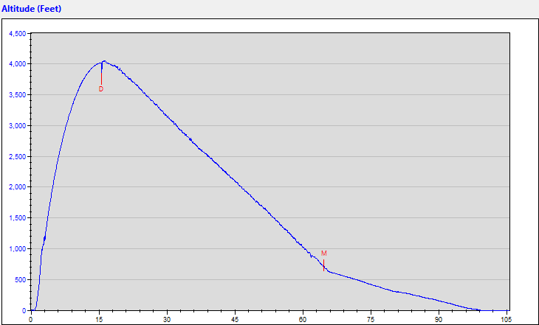
Curve 2

Plant data

3 groups:

Flight
Launch Site Control
Lab Control

